Chapter 1. Introduction

Hadoop
Hadoop is an open-source software framework for storing data and running applications on clusters of commodity hardware. It provides massive storage for any kind of data, enormous processing power and the ability to handle virtually limitless concurrent tasks or jobs

Hadoop History
As the World Wide Web grew in the late 1900s and early 2000s, search engines and indexes were created to help locate relevant information amid the text-based content. In the early years, search results were returned by humans. But as the web grew from dozens to millions of pages, automation was needed. Web crawlers were created, many as university-led research projects, and search engine start-ups took off (Yahoo, AltaVista, etc.).
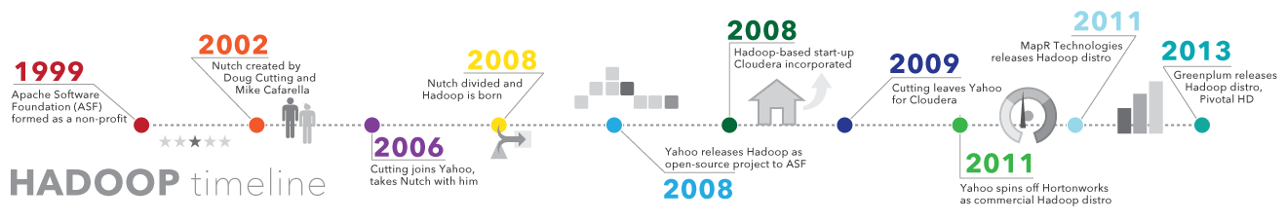
Figure 1.1 Shows the history of Hadoop till 2013
One such project was an open-source web search engine called Nutch – the brainchild of Doug Cutting and Mike Cafarella. They wanted to return web search results faster by distributing data and calculations across different computers so multiple tasks could be accomplished simultaneously. During this time, another search engine project called Google was in progress. It was based on the same concept – storing and processing data in a distributed, automated way so that relevant web search results could be returned faster.
In 2006, Cutting joined Yahoo and took with him the Nutch project as well as ideas based on Google’s early work with automating distributed data storage and processing. The Nutch project was divided – the web crawler portion remained as Nutch and the distributed computing and processing portion became Hadoop (named after Cutting’s son’s toy elephant). In 2008, Yahoo released Hadoop as an open-source project. Today, Hadoop’s framework and ecosystem of technologies are managed and maintained by the non-profit Apache Software Foundation (ASF), a global community of software developers and contributors.

Why is Hadoop important?
- Ability to store and process huge amounts of any kind of data, quickly. With data volumes and varieties constantly increasing, especially from social media and the Internet of Things (IoT), that's a key consideration.
- Computing power. The more computing nodes you use, the more processing power you have.
- Fault tolerance. If a node goes down, jobs are automatically redirected to other nodes to make sure the distributed computing does not fail. Multiple copies of all data are stored automatically.
- Flexibility. Unlike traditional relational databases, you don’t have to preprocess data before storing it. You can store as much data as you want and decide how to use it later. That includes unstructured data like text, images and videos.
- Low cost. The open-source framework is free and uses commodity hardware to store large quantities of data.
- Scalability. You can easily grow your system to handle more data simply by adding nodes. Little administration is required

[Ref1.]
Revised Oct. 18, 2018

Here is the installation process for hadoop on Ubuntu:
Step 1: Install Java
$ sudo apt-get install default-jdk
We can check JAVA is properly installed or not using following command:
$ java –version

Step 2: Install SSH
$ sudo apt-get install ssh

Step 3: Install hadoop-2.7.3
$ wget http://www-us.apache.org/dist/hadoop/common/hadoop-2.7.3/hadoop-2.7.3.tar.gz
$ tar xvzf hadoop-2.7.3.tar.gz

Step 4:Change the directory to hadoop-2.7.3

$cd hadoop-2.7.3
Step 5: Setup Configuration Files
We have to change the directory to hadoop which is inside etc directory
$cd etc
$cd hadoop
$ls
-ls command lists out all the files in the particular directory.
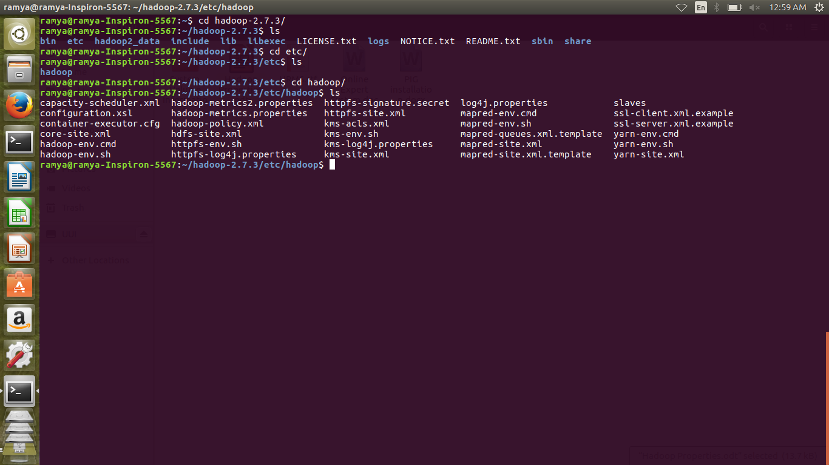
The following files should to be modified to complete the Hadoop setup:
5.1 core-site.xml
5.2 hdfs-site.xml
5.3 yarn-site.xml
5.4 mapred-site.xml
5.5 hadoop-env.sh
5.6 .bashrc

5.1 core-site.xml
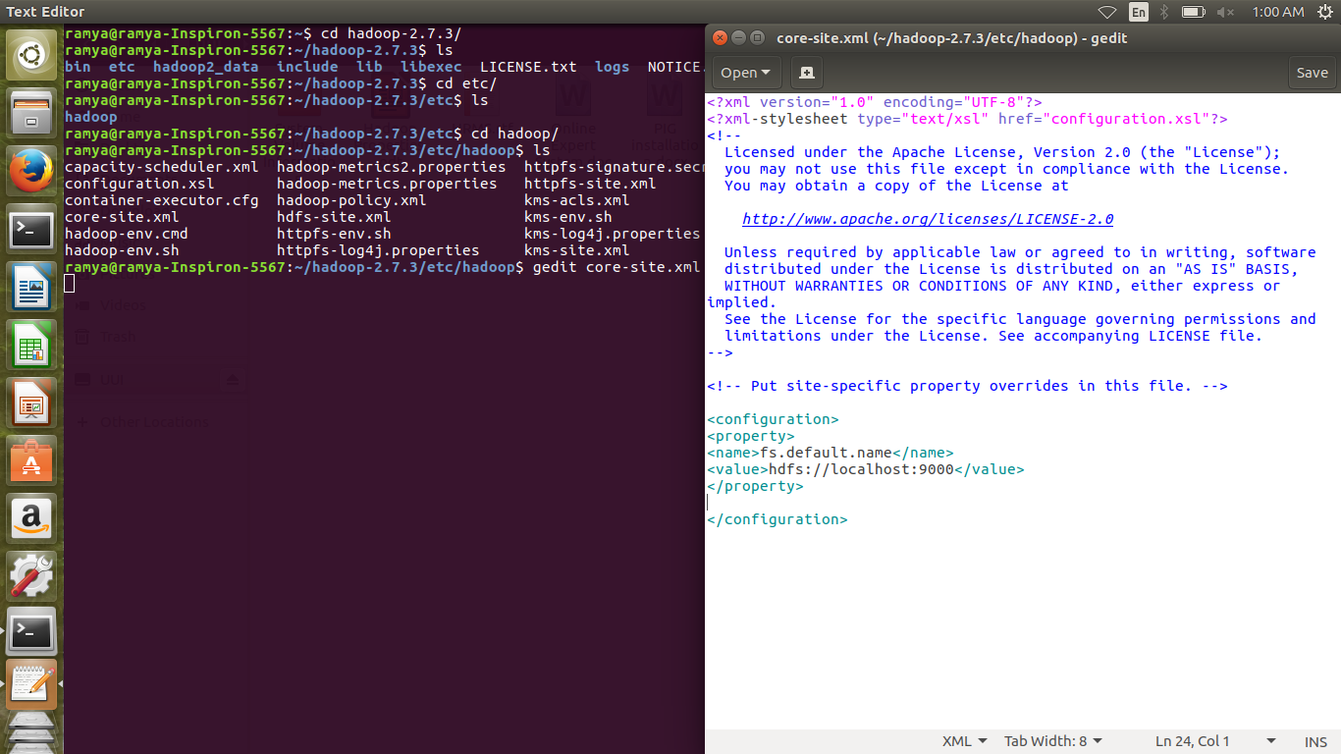
5.2 hdfs-site.xml
Here we write properties for name node and data node.
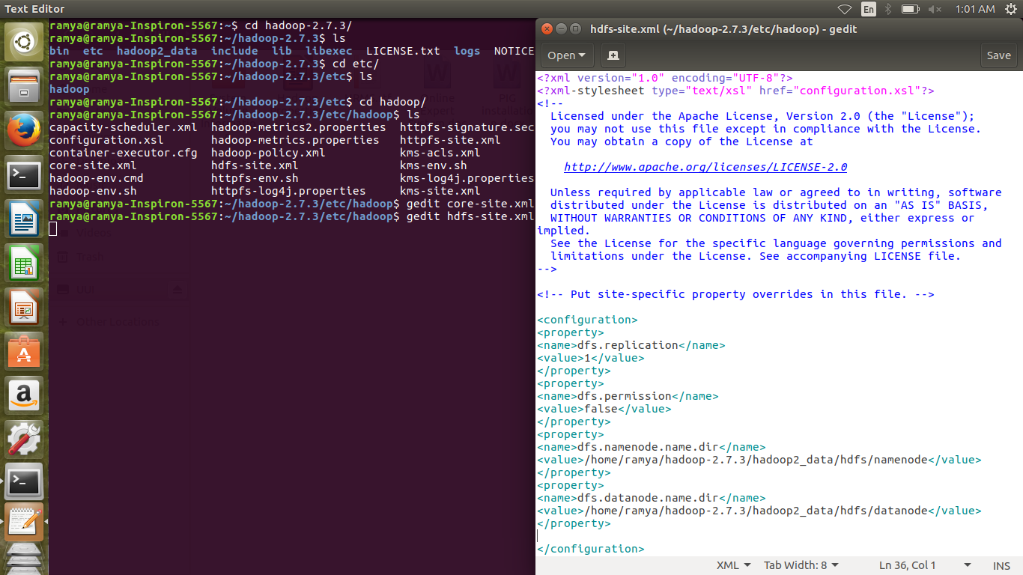
5.3 yarn-site.xml
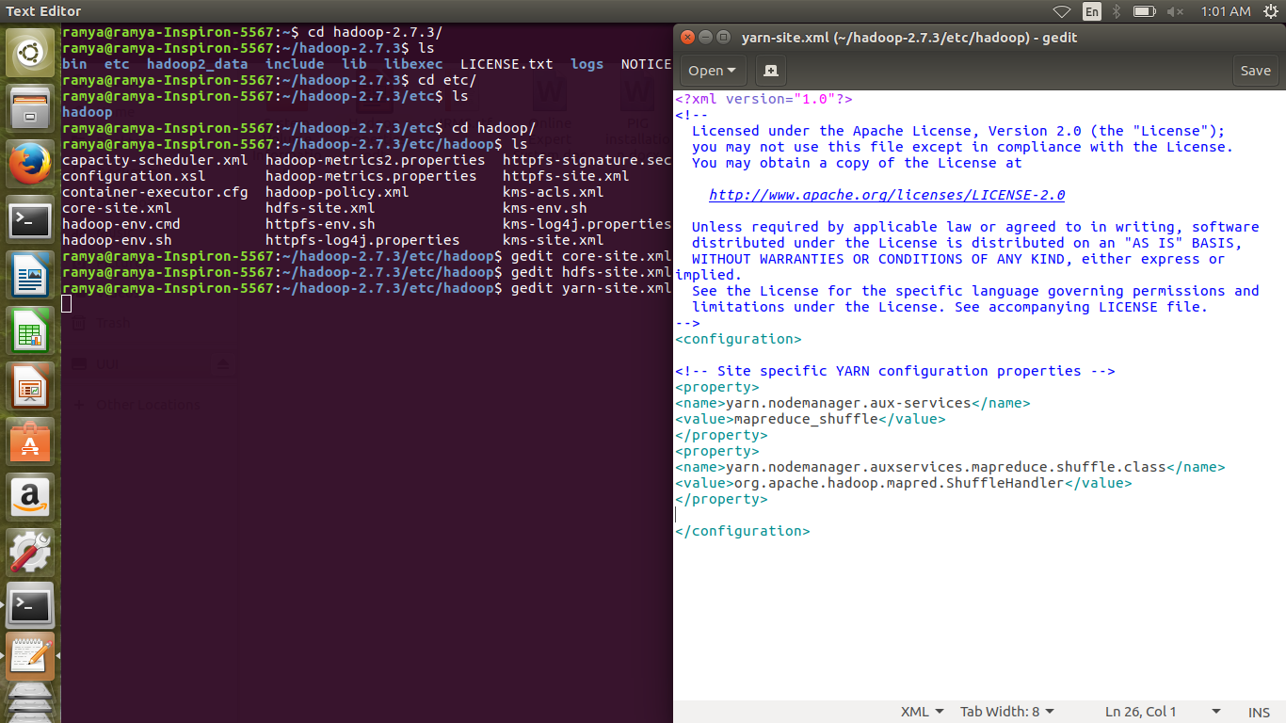
5.4 mapred-site.xml
The matter mapred-site.xml.template has to copied into mapred-site.xml using the command:
cp mapred-site-xml.template mapred-site.xml”
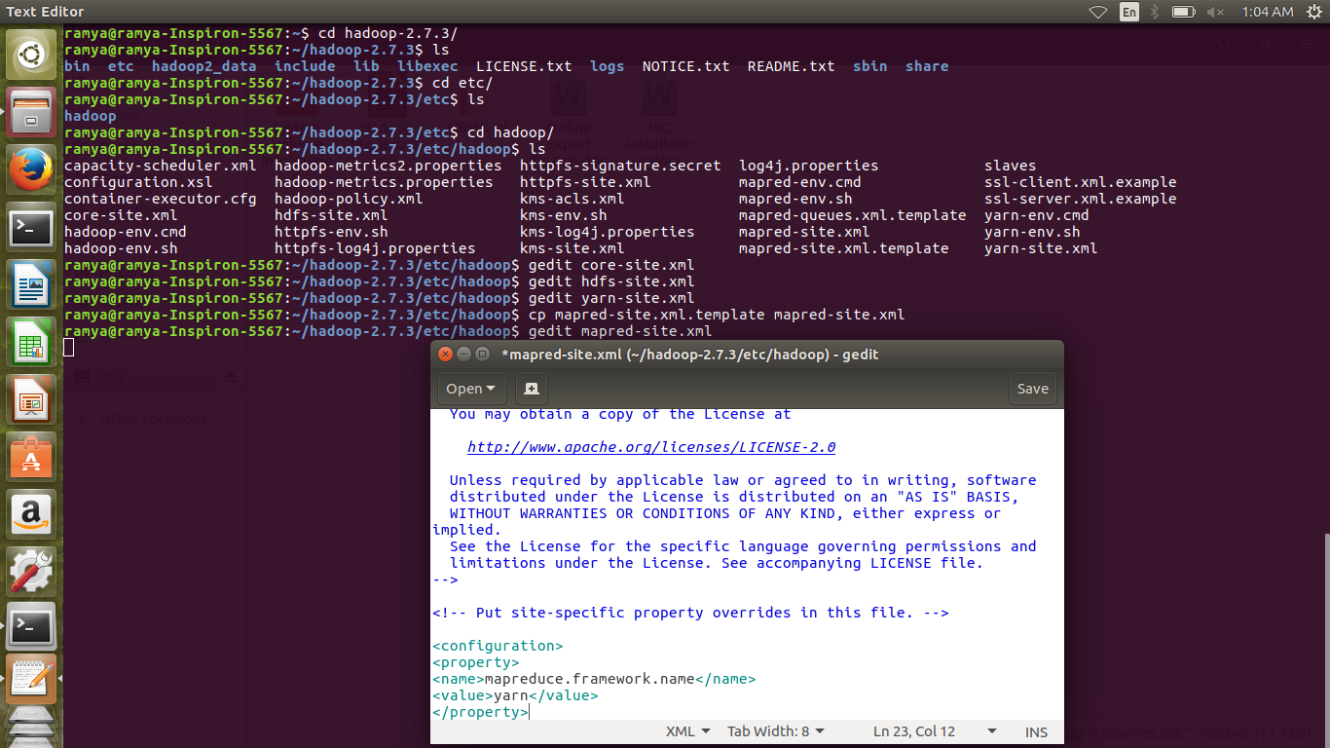
5.5 hadoop-env.sh
Here we set up the java path
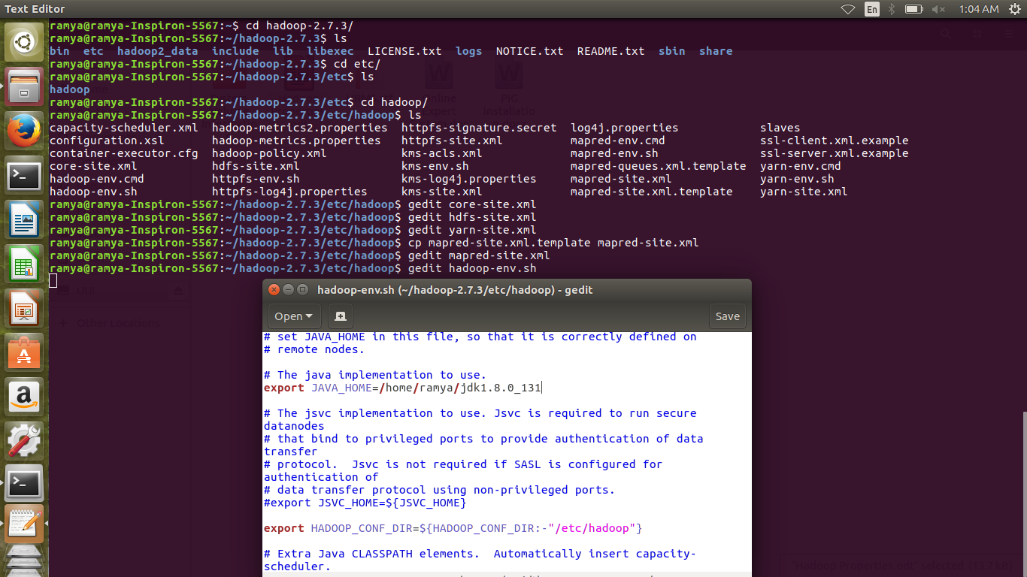

5.6 .bashrc
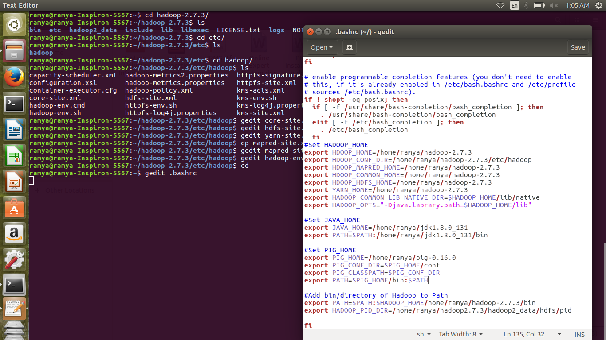
Here we setup the hadoop home, java home and directory of hadoop to path.
And after editing we save each file .
We saving this bashrc file we write the command:
source ./bashrc
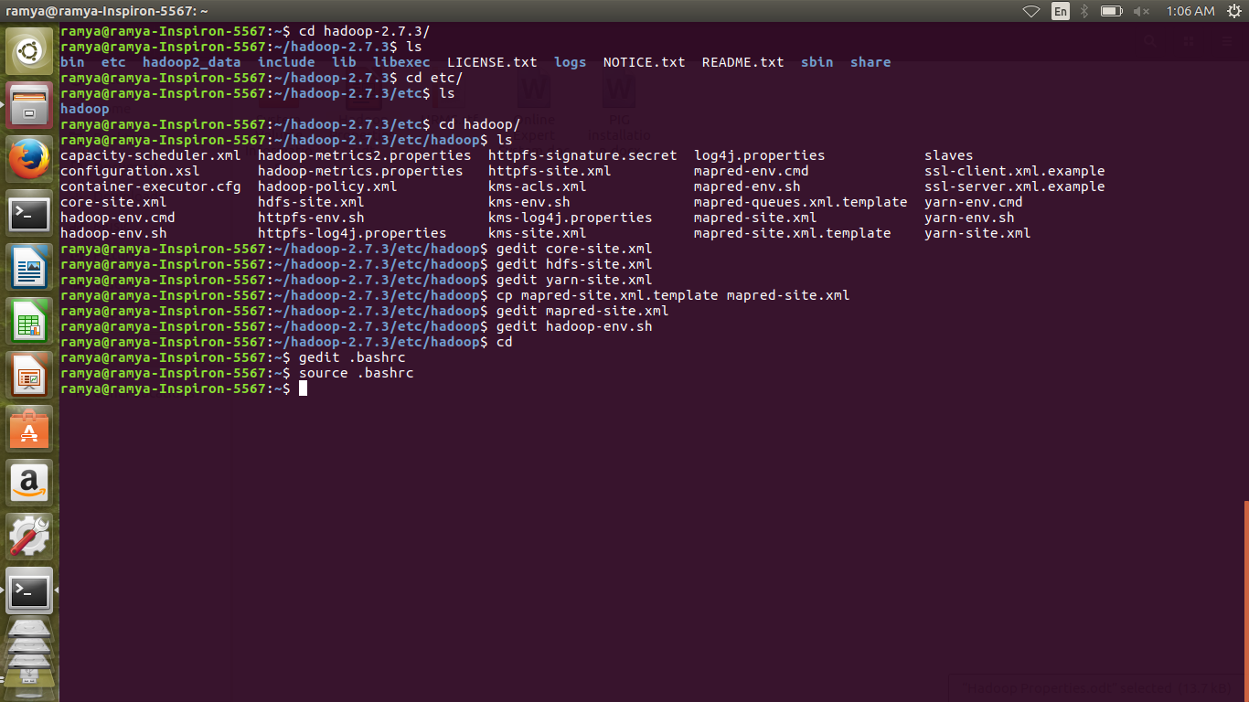

Step6: Format hadoop file system

$cd hadoop-2.7.3
$bin/hadoop namenode –format
This will format the name node and check for the message – “name node successfully formated”

Step 7: Start Hadoop Daemons
$ cd sbin
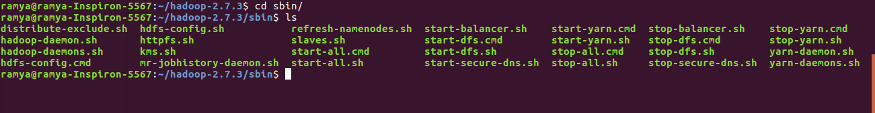
$ cd ls

$ ./start-dfs.sh
$ start-yarn.sh
We can check all daemons are properly started using following command:
$ jps
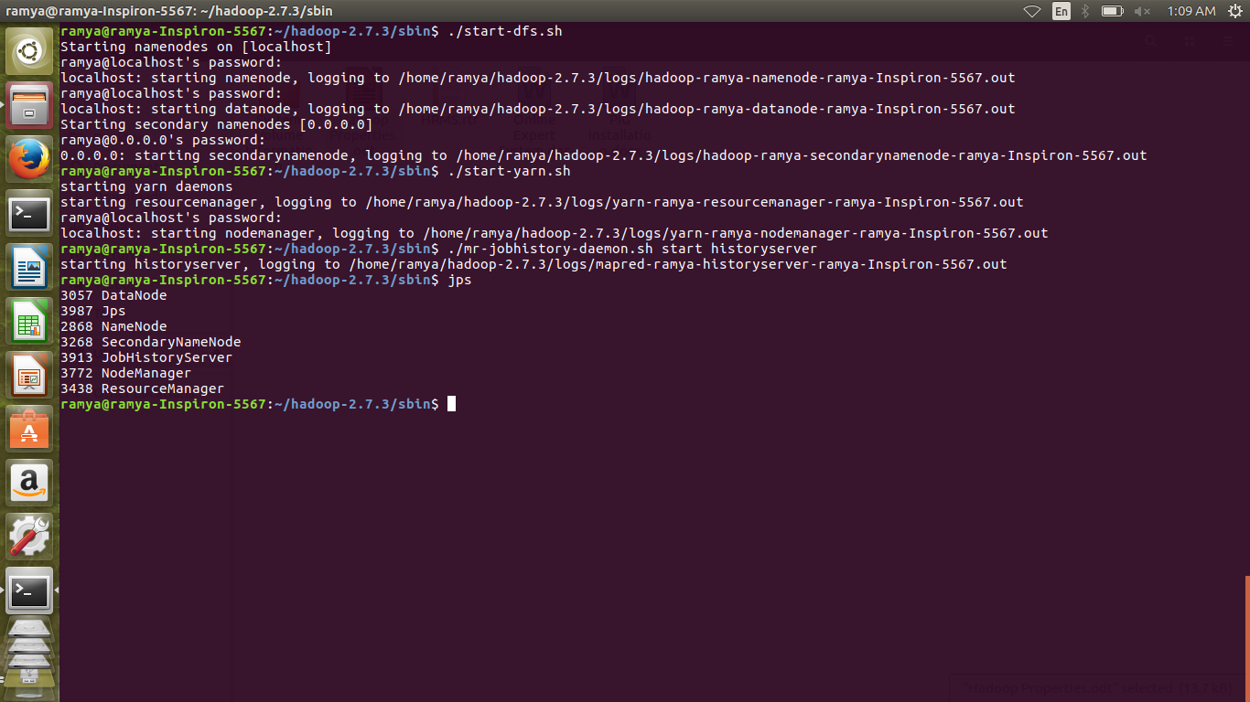

Abstract

Big data is an analytical engine that can process large volumes of data which is in tera or peta byte size, it is often confused to storing of large amount of data but it’s not. Analysis of data sets can find new correlations to spot business trends, prevent diseases, predict decisions and so on. We are implementing a project which extracts the information from Tweets in Twitter and perform Sentiment Analysis on Twitter data using bigdata. We will be getting to know about the Positive and Negative Tweets on Political Leader, who are going to stand for election and determine who maybe the next Leader. To begin with, we will be collecting real-time tweets from Twitter using Flume. Data transformation in Hadoop is completed using a process called MapReduce in Java or can be system generated by tools such as Hive (a SQL like language for Hadoop that many data analysts would be immediately comfortable with) or PIG (a procedural scripting language for Hadoop). Run queries on top of data and provide information. By doing all this we are going to provide the information about who will be the next leader.

Chapter 2. Literature Survey

Survey 1: In this survey it has been stated that, there are five key things:

- Data management strategy.
- Ownership versus stewardship of the data.
- Metadata strategy.
- Data governance, including data quality and data life cycle.
- Data usage.

With these five subjects in mind, it’s applied them to business and data analytics.

Data management strategy
When using data for analytics, consider the corporate data management strategy (if there is one). Consider the procedures outlined in the strategy and adhere to them. For example, if the analytic project is to bring in data from a third-party vendor (purchased data or data scraped from a website), the data should be introduced into the corporation based on the data management strategy. Each strategy should outline how to deal with purchased data. The strategy could include a meeting with the board to introduce the data and to recommend how to govern and manage the data over time.

Ownership versus stewardship of data used for analytics
With analytics, it is used data from many places to help us make business decisions. But who owns the data? Some companies have created data domain managers for subject areas like customer, product, etc., where those stewards basically "own" the data. But much like her husband "owning" the television remote, we must state ownership for every project. Be sure to state clearly which domain steward or subject matter expert (SME) owns the data.

Metadata collection, storage and dissemination for analytics
Sometimes in analytics is build so quickly that it doesn’t have time to think about metadata. Metadata tells us the navigation, structure, usage and definition of data. It also tells us where the data came from, frequency of updates, etc. Storing this information for data life cycle management is very important to the organization. Metadata can answer questions about when the data was last used, as well as when to retire specific analytical data. Much like clothing you haven't worn for a while, you may not need the data anymore it has not been queried in the last three months.

Data governance for analytics
Data governance, as part of a data management strategy, relies on the metadata listed above as well as the quality and life cycle of the data. Keep in mind that:
- The quality of the data is based on the requirements. Some analytical projects require data in its rawest form (no enhancements, no corrections).
- The data life cycle is also based on requirements. Some data or compilations of data are only required for a certain amount of time. The historical perspective of the data is just not important. That said, for any data coming into the enterprise, we need to understand its life cycle.

Use of data analytics
Analytics is all about usage. Data is created in a format for the business user, based on their requirements. Here's an example. I was working for a company that had a huge investment in a reporting and analytics tool. This tool had metadata stored about every query, every attribute touched or used by any individual or process. By analyzing this stored technical metadata on a monthly basis, we could determine what data and reports were no longer used. Then, based on our analysis, we contacted business users and determined what data and reports could be eliminated. It's good practice not to keep data you don't need anymore – and should be one of the foundations of the larger enterprise data strategy.

[Ref2]
November 12, 2018
Survey 2: In this survey it is said about, Sentiment Analysis in great depth. From talking about the methods and tools of Sentiment Analysis to discussing why is it so extensively used.

Sentiment Analysis, also known as Opinion Mining, refers to the techniques and processes that help organisations retrieve information about how their customer-base is reacting to a particular product or service.
In essence, Sentiment Analysis is the analysis of the feelings (i.e. emotions, attitudes, opinions, thoughts, etc.) behind the words by making use of Natural Language Processing (NLP) tools. If you’re not aware of what NLP tools do – it’s pretty much all in the name. Natural Language Processing essentially aims to understand and create a natural language by using essential tools and techniques.

Sentiment Analysis: The Math Behind It
A computer has no concept of naturally spoken language – so, we need to break down this problem into mathematics (the language of a computer). It cannot simply deduce whether something contains joy, frustration, anger, or otherwise – without any context of what those words mean.
Sentiment Analysis solves this problem by using Natural Language Processing. Basically, it recognizes the necessary keywords and phrases within a document, which eventually help the algorithm to classify the emotional state of the document.
Data Scientists and programmers write applications which feeds the documents into the algorithm and stores the results in a way which is useful for clients to use and understand.
Keyword spotting is one of the simplest techniques and leveraged widely by Sentiment Analysis algorithms. The fed Input document is thoroughly scanned for the obvious positive and negative words like “sad”, “happy”, “disappoint”, “great”, “satisfied”, and such.
There are a number of Sentiment Analysis algorithms, and each has different libraries of words and phrases which they score as positive, negative, and neutral. These libraries are often called the “bag of words” by many algorithms.
Although this technique looks perfect on the surface, it has some definite shortcomings. Consider the text, “The service was horrible, but the ambiance was awesome!” Now, this sentiment is more complex than a basic algorithm can take into account – it contains both positive and negative emotions. For such cases, more advanced algorithms were devised which break the sentence on encountering the word “but” (or any contrastive conjunction). So, the result becomes “The service was horrible” AND “But the ambiance was awesome.”
This sentence will now generate two or more scores (depending on the number of emotions present in the statement). These individual scores are consolidated to find out the overall score of a piece. In practice, this technique is known as Binary Sentiment Analysis
No Machine Learning algorithm can achieve a perfect accuracy of 100%, and this is no different. Due to the complexity of our natural language, most of the sentiment analysis algorithms are only 80% accurate, at best.

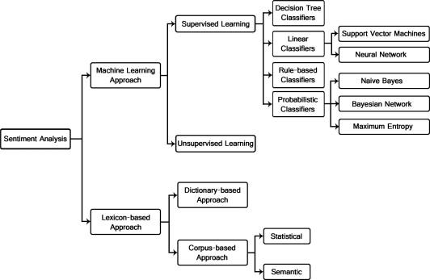
Figure 2.1 Graphical representation of Algorithms that can be used for Sentiment Analysis
The above graphic will give you a fair idea of the classification of Sentiment Analysis algorithms.
Essentially, there are two types of Machine Learning algorithms:

ML-based
You’re aware of the basic workings of any Machine Learning algorithms. The same route by followed in ML-based sentiment analysis algorithms as well. These algorithms require you to create a model by training the classifier with a set of example. This ideally means that you must gather a dataset with relevant examples for positive, neutral, and negative classes, extract these features from the examples and then train your algorithm based on these examples. These algorithms are essentially used for computing the polarity of a document,

Lexicon-based
As the name suggests, these techniques use dictionaries of words. Each word is annotated with its emotional polarity and sentiment strength. This dictionary is then matched with the document to calculate its overall polarity score of the document. These techniques usually give high precision but low recall.
There is no “best” choice out of the two, your choice of method should depend solely on the problem at hand. Lexical algorithms can achieve near-perfect results but, they require using a lexicon – something that’s not always available in all the languages. On the other hand, ML-based algorithms also deliver good results but, they require extensive training on labeled data.

[Ref3]
FEBRUARY 21, 2018

Chapter 3: System Analysis & Design
Social networking site uses opinion mining has been recently introduced to extract useful information from text and multimedia data. A new real-time method is required to extract the ideas and thoughts from this huge data. Such information can prove useful in many fields, such as economics, politics, media, culture. However, there are a lot of data on social networking sites, technologies that can efficiently process large amounts of unstructured data to obtain the necessary information are very important as fundamental technologies in social media data processing.
Social media is social interaction among people, in which they create, share, or exchange information, ideas, and pictures, videos, texts in virtual communities and networks. Social media contains many forms of multimedia information. Twitter contains various forms of information, such as video links, image links, and text data. In this, we focus on text data and we study methods for extraction of sentiment information from big-data text.
Since the data format is relatively easy and free, most social networking site data are unstructured. Unstructured data may be defined as data that has not been standardized, because its structure and shape are so complex, unlike video image data and document data. In order to extract meaningful information from large amounts of unstructured data on a social networking site, a structuring process is needed for the unstructured data. Up to now, various technologies for processing unstructured data have been studied, focusing on morphological analysis.
Various open sources associated with the processing of big data have been provided. The Hadoop ecosystem is a famous big data processing system that is most commonly used. Hadoop Distributed File System (HDFS) and MapReduce functions based on Hadoop are proposed, which collect and store a variety of data generated by social networks and analyze the sentiments of users on networks that have a lot of unstructured data.

- Sentimental Analysis
Sentiment analysis is the process of using text analytics to mine various sources of data for opinions. Often, sentiment analysis is done on the data that is collected from the Internet and from various social media platforms. Politicians and governments often use sentiment analysis to understand how the people feel about themselves and their policies.

Data is captured from different sources, such as mobile devices and web browsers, and it is stored in various data formats. Because the social media content is unstructured RDBMS, Relational Database Management System, we need tools that can process and analyze this data. However, big data technology is made to handle the different sources and different formats of the structured and unstructured data.

Every day massive amount of data is generated by social media users which can be used to analyze their opinion about any event, movie, product or politics. Conventional tools like Apache Storm analyze stream in micro-batch whereas novel tools like Apache Spark process data in real time making analyzing and processing of real time data possible.

- Steps to do Sentiment Analysis:
Data Processing:
Data processing involves Tokenization which is the process of splitting the tweets into individual words called tokens. Tokens can be split using whitespace or punctuation characters. It can be unigram or bigram depending on the classification model used. The bag-of-words model is one of the most extensively used model for classification. It is based on the fact of assuming text to be classified as a bag or collection of individual words with no link or interdependence. The simplest way to incorporate this model in our project is by using unigrams as features. It is just a collection of individual words in the text to be classified, so, we split each tweet using whitespace.

Data Filtering:
A tweet acquired after data processing still has a portion of raw information in it which we may or may not find useful for our application. Thus, these tweets are further filtered by removing stop words, numbers and punctuations.

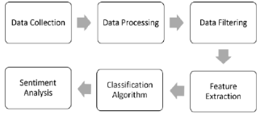
Figure 3.1 Steps of Sentiment Analysis

We will be gathering data from multiple sources in multiple formats (structured, semi-structured, or unstructured), you need to consider setting up a Hadoop cluster and a Hadoop Distributed File System (HDFS) to store your data. An HDFS provides a flexible way of managing big data:
- We move some of your analyzed data into an existing relational database management system (RDBMS).
- We store the data in HDFS for future analysis, such as comparing old data with new data.
- We discard the data if you just need the analysis of the data at the point of impact.

Data Extraction (Retrieving data from a Twitter feed):

Twitter, a popular blogging site, has a set of APIs that allows us to retrieve and manipulate tweets. First, however, we need to implement Twitter's OAuth framework. In simple terms, with this framework, an application can log in to Twitter on your behalf without you needing to log in on the Twitter website. Review the setup process on Twitter's developer site that explains how to designate the application that does this. In this process, you are assigned a key and a secret token that your application uses to authenticate on your behalf. After your application is authenticated, you can then use the Twitter APIs to fetch tweets.

Performing sentiment analysis on data:
Now that we combined the data, we can complete the sentiment analysis on a single data source, which allows for uniformity, consistency, and accuracy of our analyses. You can use Pig or Hive to do these analyses. Pig and Hive are SQL-like syntax languages that run on the Hadoop platform.

To complete sentiment analyses, we need to have a dictionary of words or word list. The dictionary includes a set of standard words that depicts positive and negative words within a context. It identifies sarcasm words, innuendos, slang terms, new vocabulary, characters, and smileys that are often used in social media.

To handle a variety of unstructured social networking site (SNS) data efficiently, a big data processing system is proposed. The proposed system is comprised of a parallel HDFS and MapReduce. HDFS, which is the Hadoop ecosystem, is used to collect and store data from a large amount of SNS data. MapReduce is used to effectively analyze large amounts of unstructured data as to the sentiment of the user.

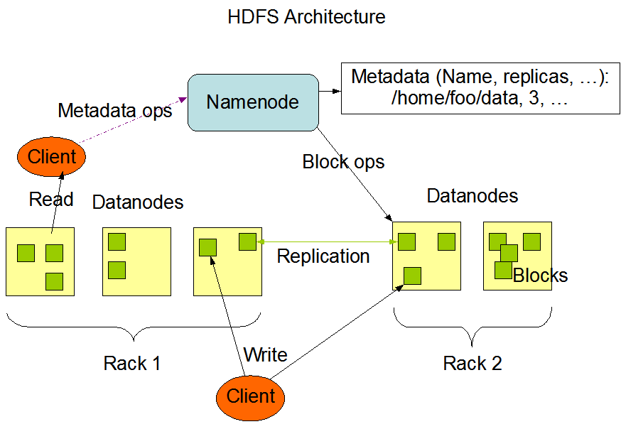

Figure 3.2 HDFS Architecture

The NameNode and DataNode are pieces of software designed to run on commodity machines. These machines typically run a GNU/Linux operating system (OS). HDFS is built using the Java language; any machine that supports Java can run the NameNode or the DataNode software. Usage of the highly portable Java language means that HDFS can be deployed on a wide range of machines. A typical deployment has a dedicated machine that runs only the NameNode software. Each of the other machines in the cluster runs one instance of the DataNode software. The architecture does not preclude running multiple DataNodes on the same machine but in a real deployment that is rarely the case.
The existence of a single NameNode in a cluster greatly simplifies the architecture of the system. The NameNode is the arbitrator and repository for all HDFS metadata. The system is designed in such a way that user data never flows through the NameNode.
HDFS is a file processing system that has a distributed processing structure. It is configured in parallel, as shown in the above Figure and each chunk node for storing data is set to 64 MB. It duplicates the name server using NFS for disaster recovery.

MapReduce:

MapReduce is a software framework developed by Google to support distributed computing, and it allows parallel programming using the function concept called Map. In this paper, it is classified into four special Map functions. They perform polarity preprocessing analysis, syntactic word analysis, morpheme analysis, and prohibitive word analysis, stage by stage. Figure below shows the process of sentiment analysis using four sentiment analysis functions. Sentiment analysis is started from the loading of sentiment analysis dictionaries. Then, the data are input and loaded to the parallel HDFS. Later, the stepwise sentiment analysis is processed by four sentiment analysis functions. Sentences that do not determine the sensitivity in the previous step move on to the next step. The results of the final sentiment analysis are stored in the database.

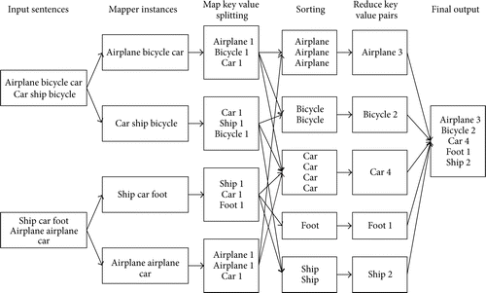

Figure 3.3 Example for MapReduce

[Ref4]
26 Aug 2014
[Ref5]
2008

Chapter 4. Methodology
"Naive Bayes Classification" is termed such because it makes the assumption that each word is statistically independent from each other word. Sentiment analysis feels quite a bit like classification: given a document, would you label it "positive" or "negative"? The main difference between classification and sentiment analysis is the idea that classification is objective but sentiment is subjective. But let's make another "naive" assumption and pretend that we don't care about that. Let's try applying Bayes to sentiment and see what happens.

Our Bayes classifier can easily be extended to use tokenizing our document two words at a time instead of one! Rather than treating the words "This" "movie" "was" "not" "great" separately -- and risk getting confused by the negation -- all we have to do is record them as pairs: "This movie" "movie was" "was not" "not great". Now our classifer knows the difference between "was great" and "not great"!

In a text classification problem, we will use the words (or terms/tokens) of the document in order to classify it on the appropriate class. By using the “maximum a posteriori (MAP)” decision rule, we come up with the following classifier:
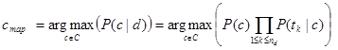
Where t_{k} are the tokens (terms/words) of the document, C is the set of classes that is used in the classification, the conditional probability of class c given document d, the prior probability of class c and the conditional probability of token t_{k} given class c.
This means that in order to find in which class we should classify a new document, we must estimate the product of the probability of each word of the document given a particular class (likelihood), multiplied by the probability of the particular class (prior). After calculating the above for all the classes of set C, we select the one with the highest probability.

UML DIAGRAMS

Use case description

Use Cases. A use case is a written description of how users will perform tasks on your website. It outlines, from a user's point of view, a system's behavior as it responds to a request. Each use case is represented as a sequence of simple steps, beginning with a user's goal and ending when that goal is fulfilled.

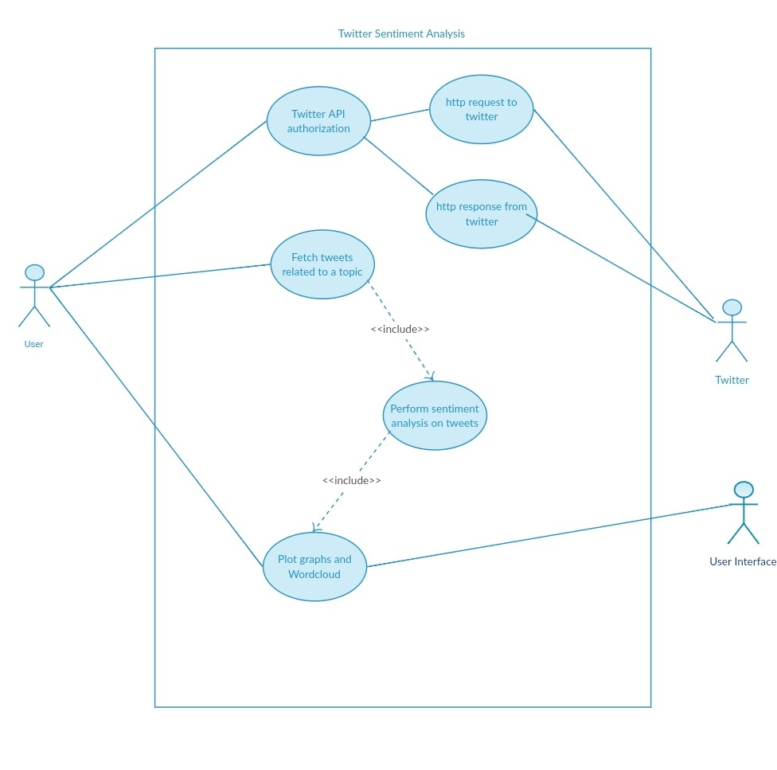
Sequence diagram

A sequence diagram simply depicts interaction between objects in a sequential order i.e. the order in which these interactions take place. We can also use the terms event diagrams or event scenarios to refer to a sequence diagram. Sequence diagrams describe how and in what order the objects in a system function.

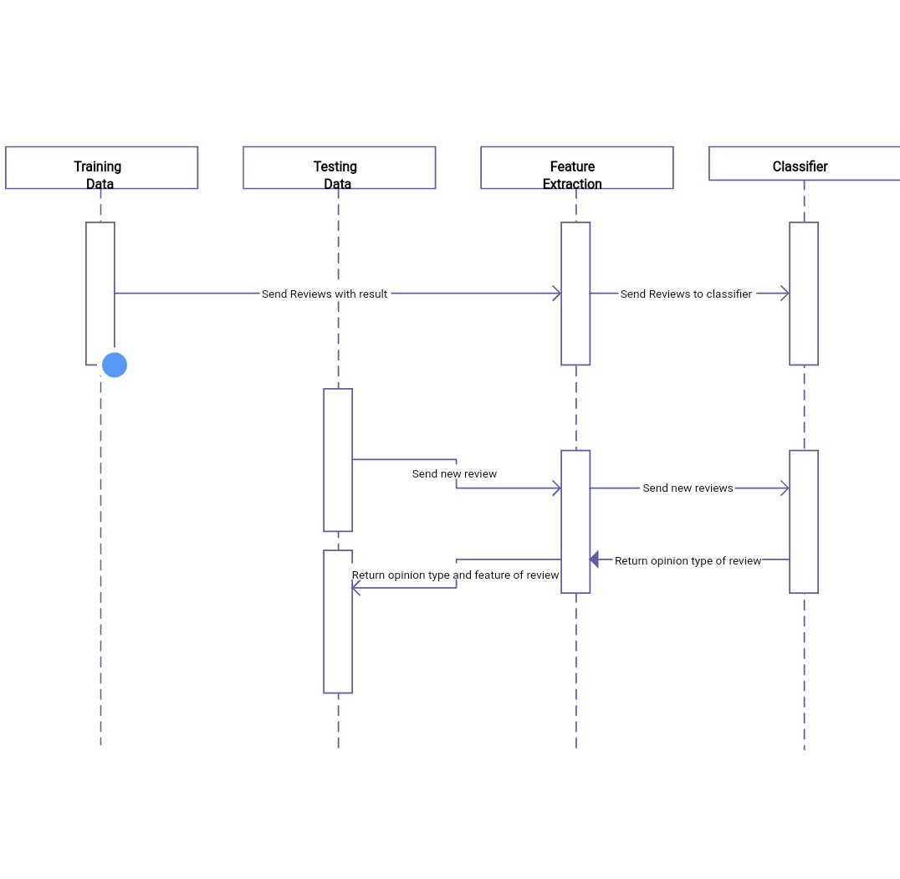

Activity diagram

Activity diagram is another important diagram in UML to describe the dynamic aspects of the system. Activity diagram is basically a flowchart to represent the flow from one activity to another activity. The activity can be described as an operation of the system. The control flow is drawn from one operation to another.
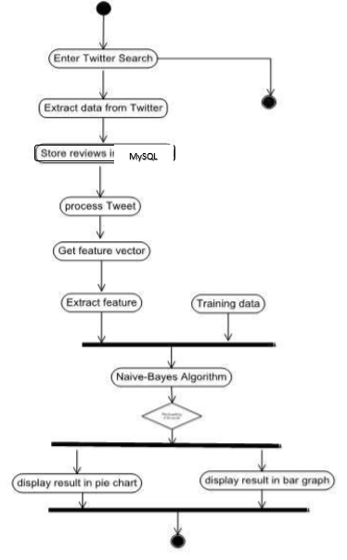
System flow diagram

A system flow diagram is a way to show relationships between a business and its components, such as customers (according to IT Toolbox.)System flow diagrams, also known as process flow diagrams or data flow diagrams, are cousins to common flowcharts

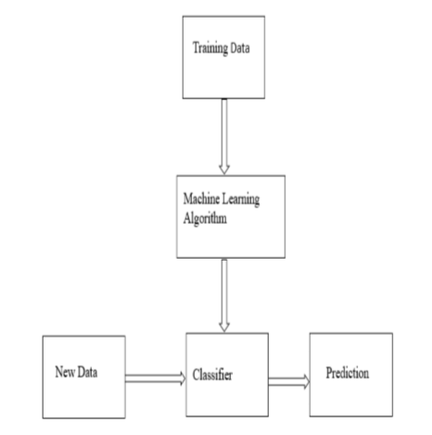
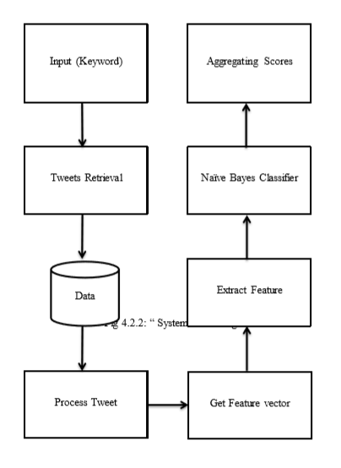
Data flow diagram

A data flow diagram is a graphical representation of the "flow" of data through an information system, modelling its process aspects. A DFD is often used as a preliminary step to create an overview of the system without going into great detail, which can later be elaborated.

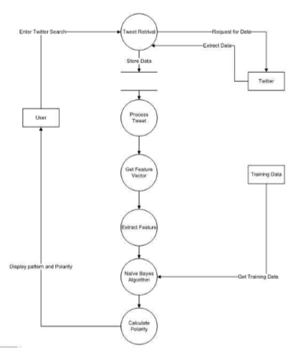
Chapter 5: Conclusion
- The proposed sentiment analysis functions have processed the data effectively.
- The results of sentiment analysis with the proposed system are more effective than the results of sentiment analysis with a manual process.

Here’s an example of a negative piece of writing because it contains hate.
Sentiment analysis and opinion mining have many applications ranging from ecommerce, marketing, to politics and any other research.

Politics
There have been at least a few academic papers examining sentiment analysis in relation to politics.
- Prediction of Indian election on the basis of twitter sentiment analysis
-Political data science : Analyzing Trump, Clinton and Sanders Tweets and Sentiment.
To sum up, from the marketing standpoint, sentiment analysis helps with:
- Identifying negative mentions about a business, a service, a company, a marketing campaign, an event in social media and on the Web
- Spotting angry customers on the verge of starting a social media crisis Analyzing how your customers react to product changes
- Spotting super happy users who, for example, are more likely to become your brand ambassadors
So, in this way our project, “Finding Next Leader by doing Sentimental Analysis using Hadoop” will show accurate results to bring out the next prominent leader from the public opinion through social network i.e. Twitter

Flow Chart
A flow chart is a graphical or symbolic representation of a process. Each step in the process is represented by a different symbol and contains a shortdescription of the process step. Theflow chart symbols are linked together with arrows showing the process flowdirection.

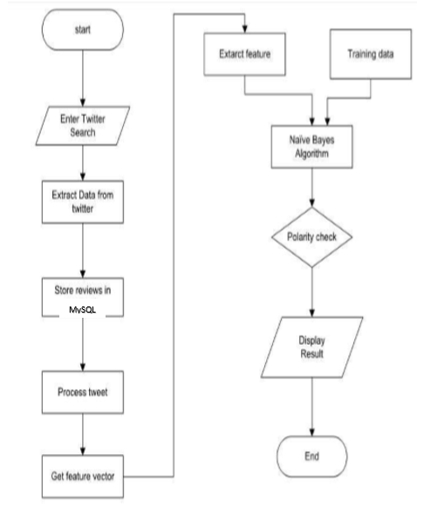
Chapter 6: References

S. No. | Author and Title | Reference
1. | Copyright © SAS Institute Inc., SAS Campus Drive, Cary, North Carolina 27513, USA. All rights reserved | Ref1
2. | JoyceNorris-Montanari  President of DBTech Solutions, In | Ref2
3. | by Amandeep Rathee | Ref3
4. | Sachin P Bappalige - Sachin | Software Engineer at IBM's Systems & Technology Group.] | Ref4
5. | by Dhruba Borthakur  Copyright ©  The Apache Software Foundation. | Ref5

